**Control Track for Enemy Waves**

**Warm -Up:** create variety of Enemy prefabs of different colors/sizes. Feel free to share prefab files with classmates

**Objective:** In this lesson students will add waves of enemies to fly at the Player

1. Click on Master Timeline to access your Timeline
2. Delete the placeholder sphere timeline
3. Delete enemy placeholders too
4. Create an Empty GameObject and name it **Enemy Waves**
5. Create another GameObject as a child of Enemy Waves and call it **Wave 1**



1. Add in 2-3 enemies right in front of your spaceship so they interact with them 2 seconds into the game. I placed mine so they’re going to move from left to right.

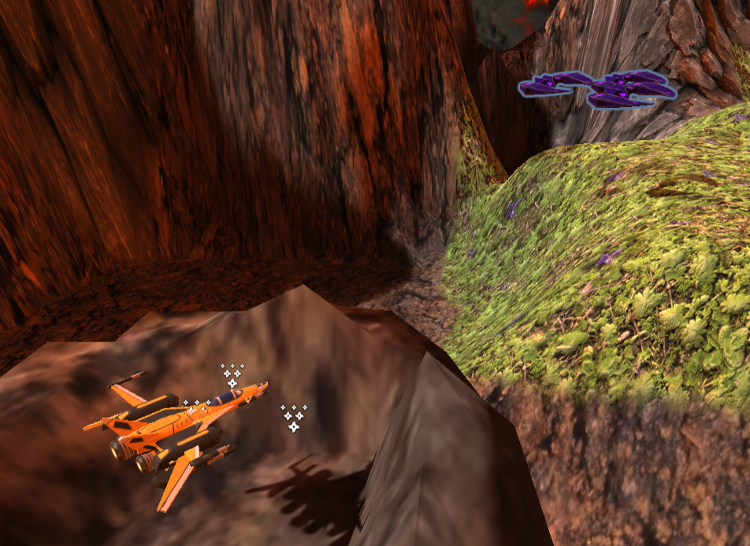

1. After setting up the enemies place them inside the Wave 1 GameObject

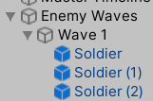

1. Click on the **Wave 1** GameObject and click on the **Timeline** tab. Then click **Create** to create a new Timeline.

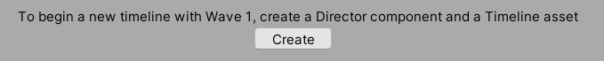

1. Go to your **Assets > Timeline** folder. Save it as **Wave 1 Timeline**
2. Delete the auto-created Wave 1 (Animator) timeline
3. **Lock** the timeline
4. Drag all enemies in Wave 1 to timeline and click **Add Animation Track**
5. **Click record** for all enemy timelines
6. Jiggle all the enemies slightly to create a starting key frame
7. Set slider to 8 seconds and drag Enemies to the right. I set mine to crash into the mountain after the interaction with the player. Pretty much if the player can’t see it, it doesn’t matter.

Now lets add some variety. About halfway through I’m going to raise the height of one enemy, move one up and to the left, stuff like that.

1. One problem that we have right now is when we move the slider for the Wave 1 we can’t see where our Player Ship is at that moment.
2. Click on **Master Timeline** and Lock it
3. Click on the **Plus** symbol in the timeline tab and select **Add Control Track**

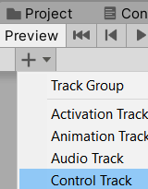

1. Grab the **Wave 1** GameObject and drag it down to the **Control Track**



1. Now if you move the slider you should see both the Player Ship move and the Enemies move across the screen.
2. Now you can drag and move **Wave 1** on the **Control Track** to speed it up or slow it down.
3. Unlock the Timeline
4. Go to your **Prefabs** folder and create a **new Folder** called **Waves**
5. Create a new Instance of this prefab and drag it on to the world FURTHER ALONG the Player Ships path and rename it to **Wave 1-2**

What do you think is going to happen when you press play?

1. **Lock** the **Master Timeline**
2. Add a **2nd Control Track** (press the Plus button)
3. Drag the **Wave 1 – Copy** to the Timeline and have it start after Wave 1
4. 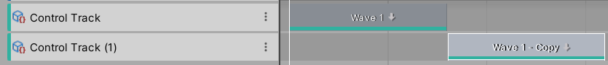
5. Press the **Timeline** **Play** button. What happened?

You should have noticed that the 2 instances are independent.

1. If you make any changes to the individual space ships they won’t be applied to the prefab.

**Challenge:**

Set Up Enemy Waves:

* 1. Create at least 5 waves of enemies
  2. Add those waves to your timeline
  3. Tune the timing so that the player can shoot and dodge the enemies.
* Increase Start Speed for lasers to 160

BEFORE NEXT LESSON

Find a picture of a pilot or someone you want to include in your game. Make some audio clips of some sound you want in your game ie “Watch Out” or “our shields are down”